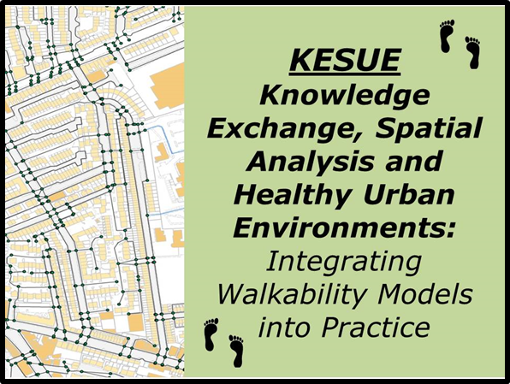

**Walkability Workshop**

**10.00-1.00**

**Monday 25th March**

**Civic Centre, Swansea**

**Places are free, but please register in advance with Anne Thomas**

**(Public Health Wales)**

**Tel: 01792 607492**

**e-mail:** [**Anne.Thomas3@wales.nhs.uk**](mailto:Anne.Thomas3@wales.nhs.uk)

**Knowledge Exc**

This half-day workshop will present the findings of a year-long project, *Knowledge Exchange, Spatial Analysis and Healthy Urban Environments* (KESUE). This has explored a range of tools that can be used to map and analyse accessibility or walkability with the aim of supporting a stronger evidence base for Healthy Urban Planning.

The purposes of the workshop are to:

* Explore the role of the built environment in influencing physical activity and health;
* Discuss how to measure and assess the walkability and accessibility of the built environment;
* Describe the activities under the KESUE project and highlight a range of case studies in how it has been used;
* Explore potential applications of these tools in promoting active travel in Swansea.

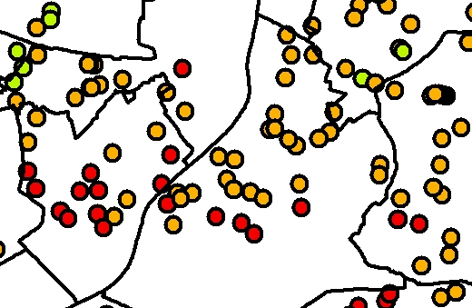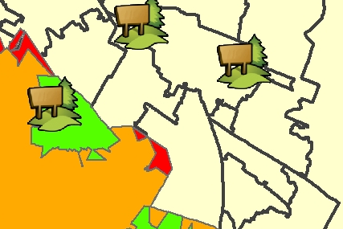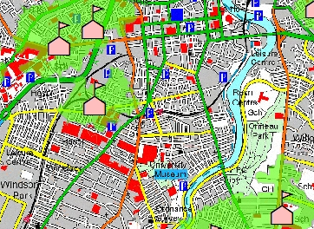KESUE is being undertaken by the School of Planning, Architecture and Civil Engineering and the Centre for Excellence in Public Health at Queen’s University Belfast, in conjunction with a range of partners that includes the Economic and Social Research Council (ESRC), Dept. of Regional Development, Belfast City Council, Derry City Council, the Public Health Agency and Belfast Healthy Cities.

For more information see: <http://www.qub.ac.uk/research-centres/KnowledgeExchangeSpatialAnalysisandHealthyUrbanEnvironments/>

[](http://www.google.co.uk/url?sa=i&source=images&cd=&cad=rja&docid=sh3lIyXIgB3z6M&tbnid=JCXILgTvykMjpM:&ved=0CAgQjRwwAA&url=http://blogs.bournemouth.ac.uk/research/2012/08/31/esrc-knowledge-exchange-opportunities-scheme-2/&ei=v6cwUandGubO0QXUwoCwAw&psig=AFQjCNHaNwg0JbKU4h4Xv-AetgmcEpAlBw&ust=1362229567506235)Walkability Workshop

Committee Room 1, Civic Centre, Swansea

Monday 25nd March 2013

Outline Programme

|  |  |
| --- | --- |
| 1400: | Introductions and purposes of the workshop |
| 1410: | Background to the KESUE project |
| 1430: | Understanding walkability, physical activity and built environment interventions  *Questions and discussion* |
| 1500: | Developing the Real Walkable Network (RWN)  *Questions and discussion* |
| 1520 | Break |
| 1545: | Walkability analysis using the RWN: Case Studies and Applications  *Questions and discussion* |
| 1610 | Discussion:  *What are the lessons, priorities and potential applications for Swansea?* |
| 1700 | Close |

The project will be led by *Professor Geraint Ellis*, of the School of Planning, Architecture and Civil Engineering at Queen’s University Belfast.

(see: <http://pure.qub.ac.uk/portal/en/persons/geraint-ellis(baeda811-7a40-4a2c-b18f-531c31a07cd7).html> )